**# Practice Questions for Making Flowcharts and Writing Pseudocodes:**

**Q1.** Draw a flowchart and write pseudocode for **"product of 2 numbers".**

Ans:

1) Flowchart:

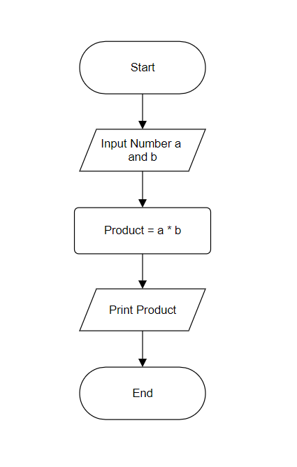

2) Pseudocode:

(i) Take input of a and b

(ii) Product = a * b

(iii) Print Product

**Q2.** Draw a flowchart and write pseudocode for **"perimeter of triangle".**

Ans:

1) Flowchart:

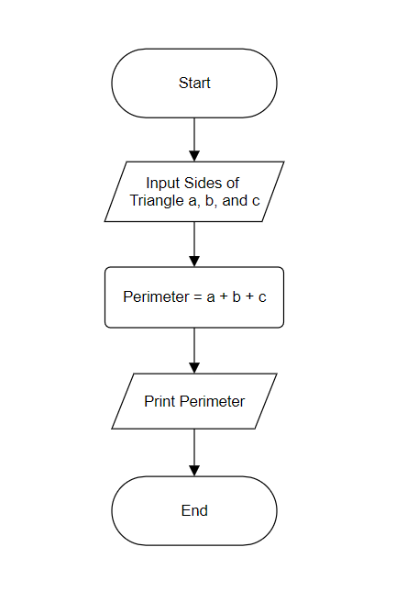

2) Pseudocode:

(i) Take input of sides of triangle a, b, and c

(ii) Perimeter = a + b + c

(iii) Print Perimeter

**Q3.** Draw a flowchart and write pseudocode for **"calculating and printing simple interest".**

Ans:

1) Flowchart:

2) Pseudocode:

(i) Take input of principle amount, rate, and time period respectively p, r, and t

(ii) Simple Interest = (P * R * T)/100

(iii) Print Simple Interest

**Q4.** Draw a flowchart and write pseudocode for **"print counting 1 to n".**

Ans:

1) Flowchart:

2) Pseudocode:

(i) Take input of n

(ii) i = 1

(iii) if (i <= n), then

Print i

i = i + 1

go to step (iii)

(iv) else, exit.

**Q5.** Draw a flowchart and write pseudocode for **"calculating and printing factorial of n".**

Ans:

1) Flowchart:

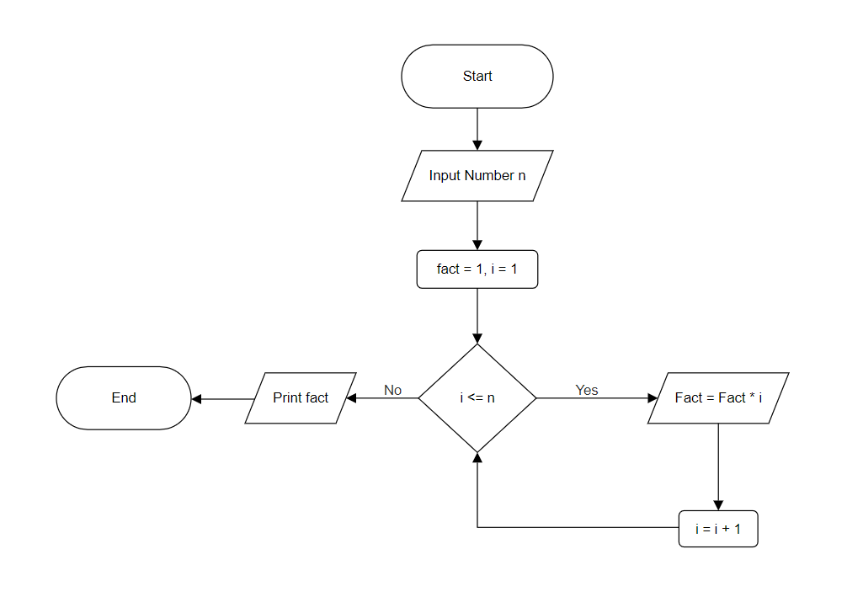

2) Pseudocode:

(i) Take input of n

(ii) fact = 1, i = 1

(iii) if (i <= n), then

Fact = fact * i

i = i + 1

go to step (iii)

(iv) else, print fact and exit.

**Q6.** Draw a flowchart and write pseudocode for **"checking whether a number is prime or not".**

Ans:

1) Flowchart:

2) Pseudocode:

  (i) Read n

(ii) i = 2

(iii) if (i < n), then

if (n % i == 0)

Print “Not Prime”, and exit.

else

i = i + 1

go to step (iii)

(iv) else, Print “Prime”, and exit.

**Q7.** Draw a flowchart and write pseudocode for **"checking whether a triangle is valid or not".**

Ans:

1) Flowchart:

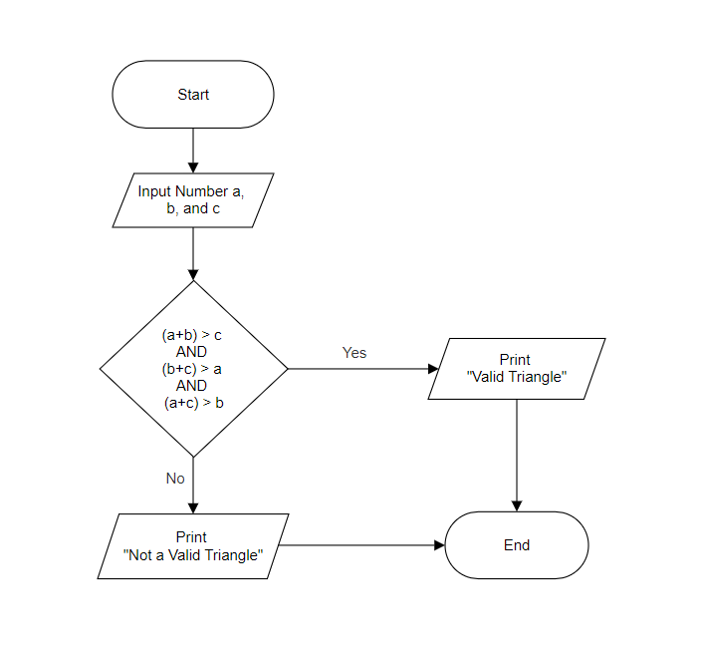

2) Pseudocode:

  (i) Take input of all the sides of a triangle in a, b, and c respectively

(ii) if ((a+b)>c AND (b+c)>a AND (a+c)>b), then Print “Valid Triangle” and exit

(iii) else, Print “Not a Valid Triangle” and exit.

**Q8.** Draw a flowchart and write pseudocode for **"print even number from 1 to n".**

Ans:

1) Flowchart:

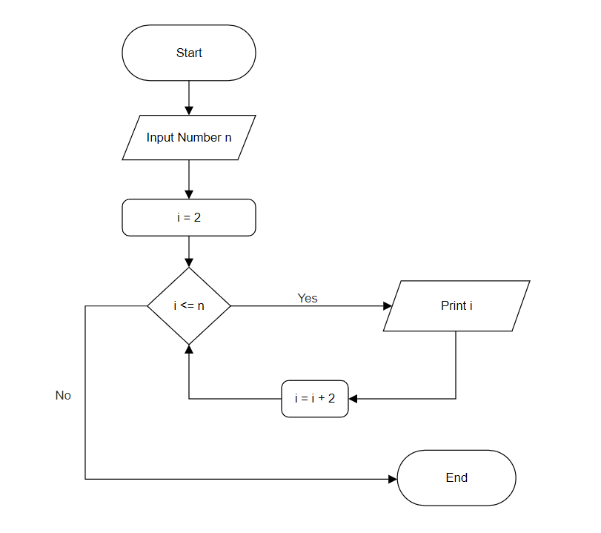

2) Pseudocode:

  (i) Take input of number n

(ii) i = 2

(iii) if (i <= n), then

print i

update i, i = i + 2

and go to step (iii)

(iv) else, exit.

**Q9.** Draw a flowchart and write pseudocode for **"finding maximum number between 3 numbers and printing it".**

Ans:

1) Flowchart:

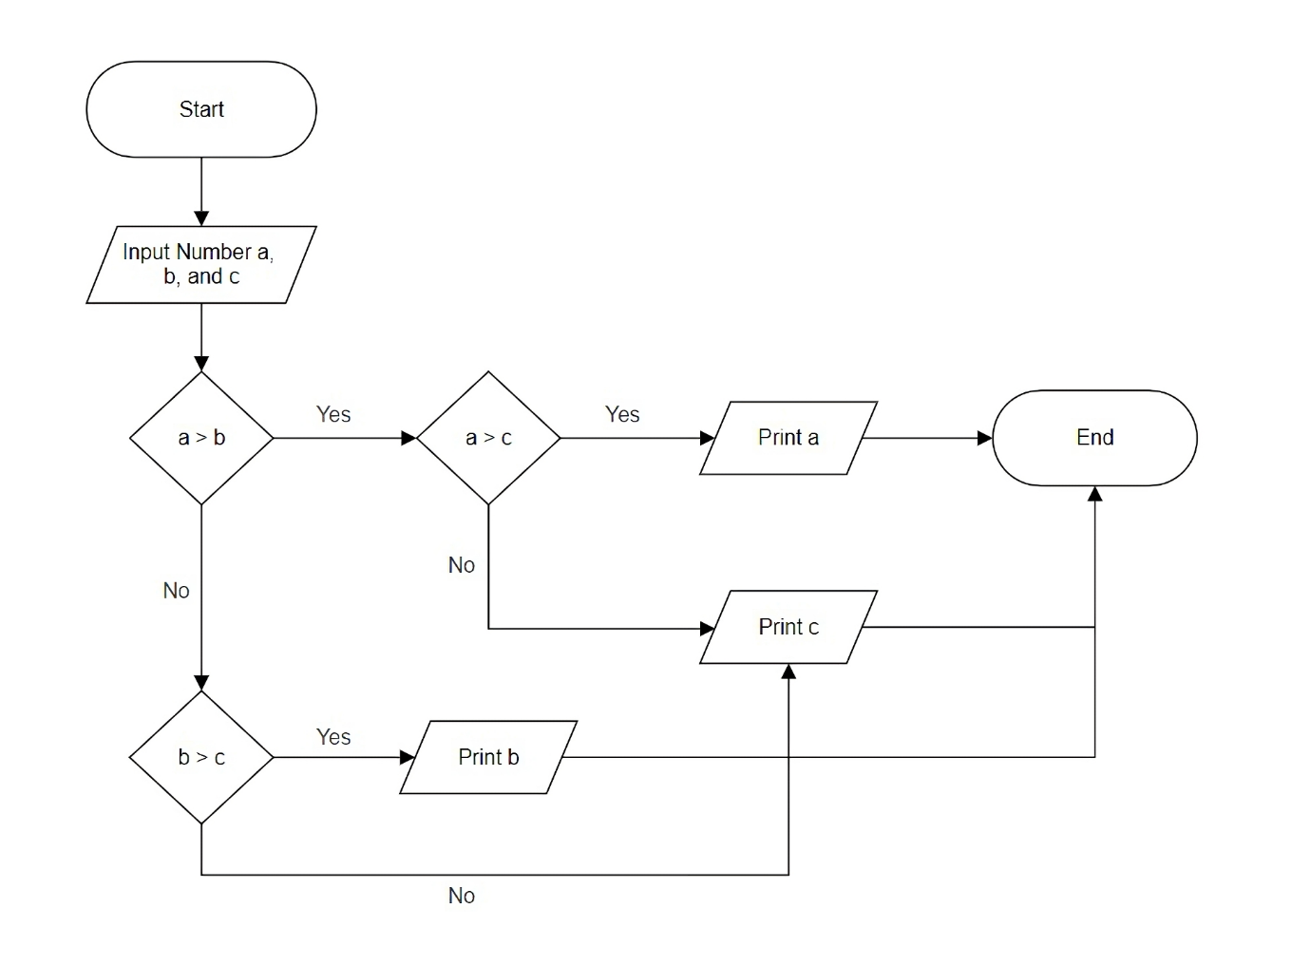

2) Pseudocode:

  (i) Read number a, b, and c

(ii) if (a > b), then

If (a > c), then

Print a, and exit

else, Print c, and exit

(iii) else,

if (b > c), then

Print b, and exit

else, Print c, and exit.

**Q10.** Draw a flowchart and write pseudocode for **"finding minimum number between 3 numbers and printing it".**

Ans:

1) Flowchart:

2) Pseudocode:

  (i) Read number a, b, and c

(ii) if (a < b), then

If (a < c), then

Print a, and exit

else, Print c, and exit

(iii) else,

if (b < c), then

Print b, and exit

else, Print c, and exit.